<!--This file created 2:29 PM 10/29/97 by Claris Home Page version 2.0-->3.8 Project
How Deep Does a Floating Ball Sink?

Figure 3.8.24 in the text shows a large cork ball of radius a = 1 floating in water of density 1. Let the ball's density be denoted by ρ. If ρ = 1/4, then Archimedes' law of buoyancy implies that the ball floats in such a way that one-fourth of its total volume is submerged. Because the volume of the whole ball of radius 1 is 4π/3, it follows that the volume of the part of the ball beneath the waterline is given by

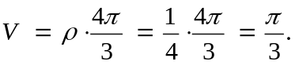 (1)

The shape of the submerged part of the ball is that of a spherical segment with a circular flat top. The volume of a spherical segment of top radius r and depth h = x (as in the figure) is given by the known formula

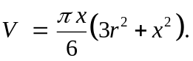 (2)

This formula is also due to Archimedes and holds for any depth x, whether the spherical segment is less than or greater than a hemisphere. For instance, note that with r = 0 and
x = 2a it gives V = 4 π a³/3, the volume of a whole sphere of radius a.

For a preliminary investigation, proceed as follows to find the depth x to which the ball sinks in the water. Equate the two expressions for V in (1) and (2), and then use the Pythagorean formula for the right triangle in the figure to eliminate r. You should find that x must be a solution of the cubic equation

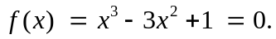 (3)

As the graph  for –4 ≤ x ≤ 4 in Fig. 3.8.25 in the text indicates, this equation has three real solutions — one in the interval (–1, 0), one in (0, 1), and one in (2, 3). The solution between 0 and 1 gives the actual depth x to which the ball sinks (why?). You can proceed to find this value of x using Newton's method.

Your Investigation: For your very own floating ball to investigate, let its density ρ in Eq. (1) be given by
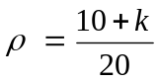
where k denotes the last nonzero digit in the sum of the final 4 digits of your student ID number. Your objective is to find the depth to which this ball sinks in the water. Start by deriving the cubic equation that you need to solve, explaining each step carefully. Then find each of its solutions accurate to at least four decimal places. Include in your report a sketch of a spherical ball with the waterline located accurately (to scale) in the position corresponding to your result for the desired depth.
Using a Graphing Calculator
In order to use a TI-83 (for instance) to solve Eq. (3), we first define the function , its derivative , and the Newton iteration function 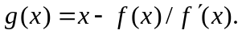 The following calculator screen shows these functions defined in the Y= menu. (Note that in defining  as Y3 we enter Y1 for f(x) and Y2 for using the VARS Y-VARS Function menu.)

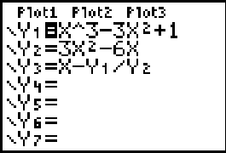

When we plot the graph after entering Xmin = -5, Xmax = 5, Ymin = -5, Ymax = 5 in the WINDOW screen, we see that our cubic equation has 3 real solutions — one close to x = –1, one a bit larger than x = 0.5, and one a bit smaller than x = 3.

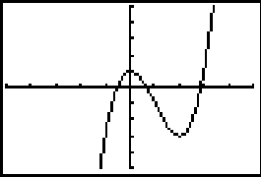

We can implement Newton's method by starting with an initial guess on the home screen and then entering Y3 X repeatedly — that is, just type Y3 X and press Enter repeatedly — to carry out the iteration. This gives:

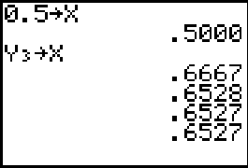

Thus we see that our ball of radius 1 and density 1/4 sinks in water to an approximate depth of 0.6527 feet, just under 8 inches.

Using Maple

We can implement Newton's method to solve Eq. (1) follows. First we define the function and the Newton iteration function
f := x -> x^3 - 3*x^2 + 1;
Df := x -> D(f)(x);
g := x - f(x)/Df(x);
We can now start with the initial guess
x := 0.5;
and then iterate the formula 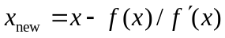 of Newton's method.
Digits := 6:
x := g(x);
x := .666667

x := g(x);
x := .652777

x := g(x);
x := .652705

x := g(x);
x := .652705

Thus the depth to which the ball sinks in the water is about 0.6527 feet, or just under 8 inches.

Using Mathematica

We can implement Newton's method to solve Eq. (1) follows. First we define the function and the Newton iteration function
f := x -> x^3 - 3x^2 + 1;
g := x - f(x)/f'(x);
We can now start with the initial guess
x := 0.5;
and then iterate the formula of Newton's method.

x = g[x];
0.666667

x = g[x];
0.652778

x = g[x];
0.652704

x = g[x];
0.652704

Thus the depth to which the ball sinks in the water is about 0.6527 feet, or just under 8 inches.

Using MATLAB

We can implement Newton's method to solve Eq. (1) follows. First we define the function and its derivative.
f = inline('x^3 - 3*x^2 + 1')
Df = inline('3*x^2 - 6*x')
We can now start with the initial guess
x := 0.5;
and then iterate the formula of Newton's method.

x = x - f(x)/Df(x)
x =
0.6667

x = x - f(x)/Df(x)
x =
0.6528

x = x - f(x)/Df(x)
x =
0.6527

x = x - f(x)/Df(x)
x =
0.6527

Thus the depth to which the ball sinks in the water is about 0.6527 feet, or just under 8 inches.

